**MURDER MYSTERY INVESTIGATION REPORT**

**BY**

**SOLOMON JOSHUA OLUMIDE**

**OVERVIEW:**

A crime has taken place and the detective needs your help. The detective gave you the crime scene report, but you somehow lost it. You vaguely remember that the crime was a murder that occurred sometime on Jan.15, 2018 and that it took place in SQL City. Start by retrieving the corresponding crime scene report from the police department’s database. Figure out who committed the crime with the details you remembered above.

**This report highlights the analysis of a crime committed in the SQL city on January 15 using the scene report from the Police department’s Database.**

The following Steps were carried out to figure out who committed the crime.

**Step 1:**

I queried the police department database to show the columns on the crime_scene report, using the following syntax:

**SELECT \***

**FROM crime_scene_report**

The table returned a result set showing details of date, type, description, and city.

**Step 2:** I filtered the table with the detective brief, the brief identified that the crime was a murder, it occurred sometime on Jan.15, 2018 and that it took place in SQL City.

**SELECT \***

**FROM crime_scene_report**

**WHERE type = "murder" AND date = 20180115 and city ="SQL City"**

From the query result set description column- Security footage shows that were 2 witnesses. The first witness lives at the last house on "**Northwestern Dr"** and the second witness, named **Annabel,** lives somewhere on **"Franklin Ave”.**

**Step 3:**

The addresses obtained from the result set will be used to find the **ID and name** of the **first witness**. This is done by querying the **Person table** and filtering it with the address **“Northwestern Dr".** The first witness lives at the last house, so I ordered the witness’s street name in descending order and limit it by 1 so that I can see the name of the person living in the last house on Northwestern Dr Street.

**SELECT name, id, address_street_name**

**FROM person**

**Where address_street_name = 'Northwestern Dr'**

**ORDER BY address_number DESC**

**LIMIT 1**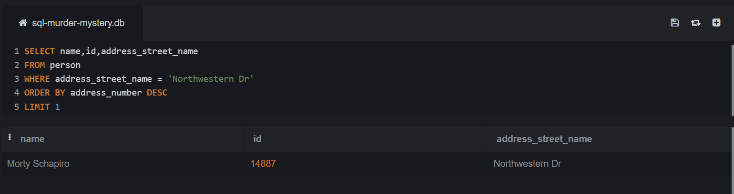

The name of the first witness obtained is **Morty Schapiro** with **ID number 14887.**

**Step 4:**

The second witness **ID** number will be retrieved using their name and address. This is done by querying the **Person table** and filtering it with the witness’s name and address: **“Annabel and Franklin Ave".**

**SELECT name, id, address_street_name**

**FROM person**

**WHERE name LIKE '%Annabel%' AND address_street_name = 'Franklin Ave'**

The name of the second witness obtained is **Annabel Miller** with **ID number 16371.**

**Step 5:**

After retrieving the ID of the two witnesses,I checked the database schema, and the **schema diagram** showed that the **person and interview table** has **primary and foreign key**. The **person table** has the primary key (id), and the **interview table** has the foreign key (person_id). These keys will be used to **join** both tables together and retrieve relevant information by leveraging the relationships between them.

I joined the person table and interview table to check the details of each witness transcripts using both **ID**.

**SELECT person.id, person.name, interview. transcript**

**FROM person**

**Join interview.**

**ON person.id = interview.person_id**

**

* **The First Witness- Morty Schapiro transcript:**

"I heard a gunshot and then saw a man run out. He had a ""Get Fit Now Gym"" bag. The membership number on the bag started with ""48Z"". Only gold members have those bags. The man got into a car with a plate that included ""H42W""

* **The Second Witness- Annabel Miller transcript:**

I saw the murder happen, and I recognized the killer from my gym when I was working out last week on January the 9th.

**Step 6:**

The witness’s transcript from the interview table results set shows that the killer is a man and a gym member. To get the membership_id of who committed the crime.

I wrote a query to check the **get_fit_now_member table** and filtered the table based on what the first witness (**Morty Schapiro**) mentioned-**Membership number with”48Z** on a bag which is identified with Gold- **Membership status.**

**SELECT \***

**FROM get_fit_now_member**

**

The query result set shows that there are only two members (**Joe Germuska and Jeremy Bowers)** with gold membership status and their Membership_id are as follows (**48Z7A and 48Z55**) and their person_id is (**67318, 28819)**

**Step 7:**

Based on the second witness transcript - **Annabel Miller (**She mentioned that she was working out on the **9th of January**).

I wrote a query to check the **get_fit_now_check_in table** and filtered it with the 2membership id from the first witness transcript **(48Z7A and 48Z55).**

The query result set shows that the **two members with gold membership status** and Membership_id (**48Z7A and 48Z55**) both checked in on the **9th of January 2018.**

**Step 8:**

From the findings I have an opinion that the crime was committed between (**Joe Germuska** and **Jeremy Bowers** as they both checked in on the **9th of January** and based on the first witness interview transcript report by (**Morty Schapiro-** mentioned thatthe man got into a car with **a plate** that included **""H42W**"".)

To identify the main suspect who committed the crime between these two, I used the **schema diagram** to join the **person table** and driver **license table** together because they both have primary and foreign key(id), and I filtered it with their **person_id** to find out who has a car registered with the plate **‘H42W’**.

**SELECT person.name,drivers_license.plate_number,drivers_license.gender,person.address_number,person.address_street_name,person.ssn**

**FROM person**

**JOIN drivers_license**

**ON drivers_license.id = person.license_id**

**

From the Query result, it shows that Jeremy bowers has a car with a plate_number **H42W** as mentioned by the first witness and his gender reveal that he is male and reside at 530, Washington PI, Apt 3A.

**Step 9:**

From these findings, **Jeremy Bowers** is the main suspect based on the two-witness description. However, to confirm that he was the one who committed the murder, I went further to check the interview table for his transcript using his person_id (**67318)**

**SELECT \***

**FROM interview**

**

The transcript result set shows the suspect **Jeremy Bowers- mentioned this** "I was hired by a woman with a lot of money. I don't know her name, but I know she's around 5'5"" (65") or 5'7"" (67”). She has red hair, and she drives a Tesla Model S. I know that she attended the SQL Symphony Concert 3 times in December 2017.”

**Step 10:**

Now, we can see that **Jeremy Bowers** is the one who committed the murdered, but he was hired by a woman, and he provided information about the main culprit. This information was used in writing a query to retrieve the name of the woman who hired him.

**SELECT person.name, person. address_number, person. address_street_name, person.ssn from person**

**JOIN drivers_license**

**ON person.license_id = drivers_license.id**

**JOIN facebook_event_checkin**

**ON person.id=facebook_event_checkin.person_id**

**WHERE facebook_event_checkin.event_name is 'SQL Symphony Concert' AND facebook_event_checkin.date LIKE '%201712%'**

**AND drivers_license.car_make is 'Tesla' AND drivers_license.car_model is 'Model S'**

**AND gender is 'female' AND drivers_license.height BETWEEN 65 and 67 AND drivers_license.hair_color is 'red'**

**GROUP by person.name**

**HAVING count(*) == 3**

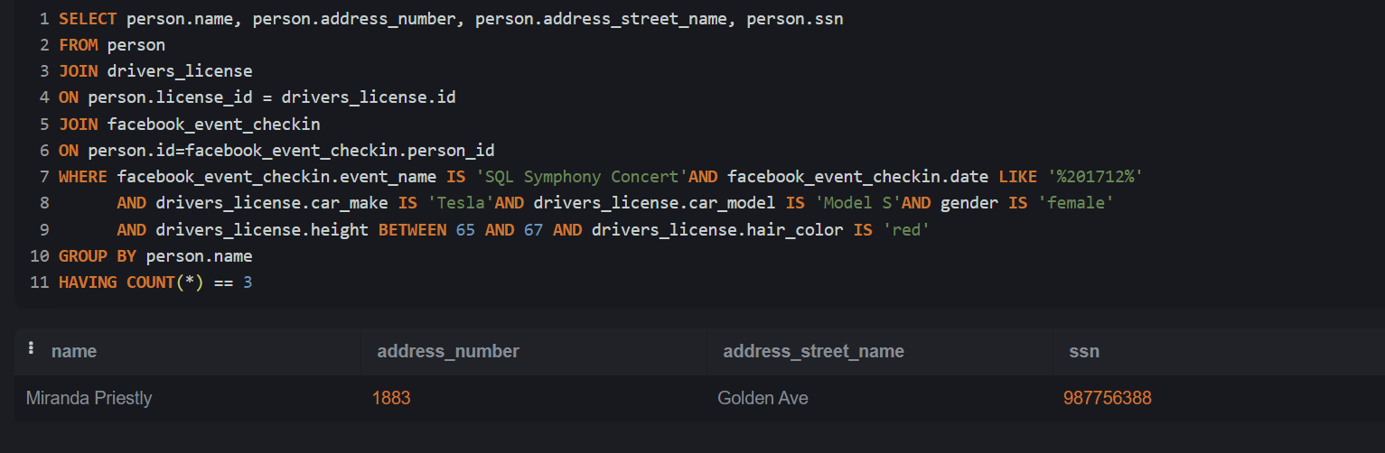

**Summary:**

The result set shows that **Miranda Priestly** who live in **1883, Golden Ave** with the **Ssn:987756388** was the woman who hired **Jeremy Bower** to commit the murder.

However, to be sure that these are the brains behind the crime, I queried the solution table and it showed this result set.